**Downscaling of satellite-based air quality map using ai/ml**

**A PROJECT REPORT**

***Submitted by***

**Shivansh Sharma 12106075**

**Alla Krishna Sai Reddy 12115551**

**Gaurav Sureshrao Gapak 12115971**

***in partial fulfillment for the award of the degree***

***of***

**Bachelor of Technology**

**IN**

**Computer science & engineering**



**Lovely Professional University, Punjab**

**2025**

**Lovely Professional University, Punjab**

**BONAFIDE CERTIFICATE**

Certified that this project report **“Downscaling of satellite based air quality map using ai/ml”** is the bonafide work of “ **Shivansh Sharma, Alla Krishna Sai Reddy, Gaurav Sureshrao Gapak ”** who carried out the project work under my supervision.

Shivansh Sharma   
Alla Krishna Sai Reddy   
Gaurav Sureshrao Gapak

**SIGNATURE**

**SIGNATURE**

**HEAD OF THE DEPARTMENT**

**SIGNATURE**

**SUPERVISOR**

Department of Machine Learning, CSE, Lovely Professional University, Punjab

**APPENDIX III**

(A typical specimen of table of contents)

<Font Style Times New Roman>

**TABLE OF CONTENTS**

|  |  |  |
| --- | --- | --- |
| **CHAPTER NO.** | **CHAPTER NAME** | **PAGE NO.** |
|  | **Title Page** | **i** |
|  | **Bonafide Certificate** | **ii** |
|  | **Table of Contents** | **iii** |
|  | Abstract | **iv** |
| 1. | Introduction of the Project | **iv** |
| 2. | Problem Description | **iv** |
| 3. | Objectives | **iv** |
| 4. | Related Work/Literature Review | **v** |
| 5. | Proposed Methodology | **v** |
| 6. | Implementation Plan | **v** |
| 7. | Expected Outcome | **v** |
| 8. | Project Timeline | **vi** |
| 9. | Limitation and Challenges | **vi** |
| 10. | Conclusion | **vi** |
|  | References | **vi** |
|  | Appendices (If Any) | - |

**Abstract**

Air quality data from satellites is often low in resolution, making it difficult to analyze local pollution levels accurately. This project focuses on improving the resolution of satellite-based air quality maps using Artificial Intelligence (AI) and Machine Learning (ML). The main problem is the lack of high-resolution air quality data, which affects environmental research and policy-making. To solve this, we use simple ML models to enhance the resolution of satellite data. The expected outcome is a more detailed air quality map that helps researchers and policymakers make better decisions.

**1. Introduction**

Air pollution is a critical global issue that impacts public health, climate change, and overall environmental quality. High levels of air pollution are associated with respiratory diseases, cardiovascular conditions, and reduced life expectancy. To monitor air quality, satellites provide large-scale data covering various pollutants, such as PM2.5, NO2, and CO. However, the resolution of satellite imagery is often too coarse to be useful at a local level, where precise air quality assessments are necessary for effective decision-making. The ability to downscale satellite-based air quality maps to a finer resolution would help researchers, policymakers, and the general public understand air pollution patterns more accurately.

Traditional methods for air quality estimation involve statistical interpolation techniques that may not always capture complex spatial relationships between pollutants. AI and ML techniques provide a more robust approach by learning patterns from high-resolution ground-based sensors and applying them to satellite imagery. The motivation for this project stems from the need to bridge the gap between low-resolution satellite data and high-resolution ground-based observations. By leveraging AI/ML models, this study aims to generate fine-grained air quality maps, enabling better environmental monitoring and policy formulation.

**2. Problem Statement**

* **Problem**: Satellite air quality maps have low resolution, limiting their usefulness.
* **Challenges**: Lack of fine-grained data, need for computational efficiency, and accurate model training.

**3. Objectives**

* Improve the resolution of satellite-based air quality data.
* Use AI/ML techniques to enhance spatial details.
* Validate results using real-world air quality datasets.

**4. Literature Review**

* Summary of previous research on satellite air quality mapping.
* Comparison of traditional statistical methods vs. AI-based methods.
* Evaluation of existing machine learning approaches for downscaling air quality data.

**5. Proposed Methodology**

**Data Collection and Description**

The dataset will be sourced from publicly available satellite air quality repositories, such as NASA’s MODIS and Sentinel-5P datasets. These datasets provide air quality indicators like PM2.5, NO2, and O3 at low resolution. To improve accuracy, data from ground-based monitoring stations will be integrated.

**Data Preprocessing Techniques**

* **Cleaning**: Removing missing values and noise.
* **Normalization**: Scaling values for consistency.
* **Feature Engineering**: Identifying key patterns in air pollution data.

Machine Learning Algorithms and Evaluation Metrics: The project will primarily utilize Convolutional Neural Networks (CNNs) and Generative Adversarial Networks (GANs

**Evaluation Metrics**

* **Root Mean Squared Error (RMSE)**: Measures the difference between predicted and actual values.
* **Mean Absolute Error (MAE)**: Calculates the average error magnitude.
* **Peak Signal-to-Noise Ratio (PSNR)**: Evaluates the quality of enhanced air quality maps.

**Model Training & Validation**

* The dataset will be split into training and testing sets.
* Models will be trained using TensorFlow with hyperparameter tuning.
* Performance will be validated using real-world air quality data.

**6. Implementation Plan**

**Technologies & Tools**

* Python, TensorFlow, Scikit-learn, Pandas, NumPy.

**Software & Hardware Requirements**

* Python environment with required libraries.
* Standard PC with GPU for model training.

**System Architecture**

* **Data Input → Preprocessing → Model Training → Prediction → High-Resolution Map Output**.

**7. Expected Outcomes**

* Higher resolution air quality maps.
* Improved accuracy of air pollution monitoring.
* Practical applications in environmental research and policymaking.

**8. Project Timeline**

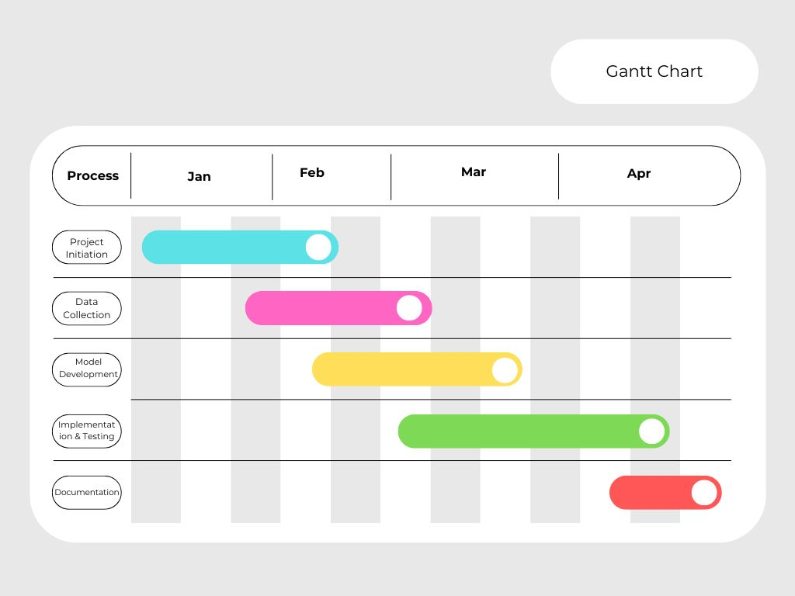

**9. Limitations & Challenges**

* Data quality issues (incomplete or noisy data).
* Computational requirements for large datasets.
* Model accuracy and generalization.

**10. Conclusion**

This project enhances satellite air quality maps using AI/ML, making them more useful for decision-making. Future work can explore deep learning models for further improvements.

**11. References**

**"Downscaling of Satellite Air Quality Data Using Deep Learning"** – Proposes DL-Air, a deep learning model for improved air quality forecasting. *(ResearchGate)*

**"Comparing ML Methods for Downscaling Air Temperature"** – Evaluates ML models like Random Forests and Gradient Boosted Trees for downscaling air temperature. *(MDPI)*

**"Downscaling Ozone Data Using Gradient-Boosted Trees"** – Uses ML to enhance ozone resolution from 5×5 km to 1×1 km. *(ACP Copernicus)*

**"DL4DS – Deep Learning for Downscaling"** – Introduces a Python library for deep learning-based downscaling in Earth Science. *(ArXiv)*

**"Bayesian Model for PM2.5 Estimation"** – Uses satellite data and Bayesian modeling to refine daily PM2.5 estimates in the U.S. *(ArXiv)*